APPENDIX A — DUBAI / ABU DHABI CRANE APPROVAL WORKFLOW
Authority Approval and Independent Certification Milestones for Crane Erection

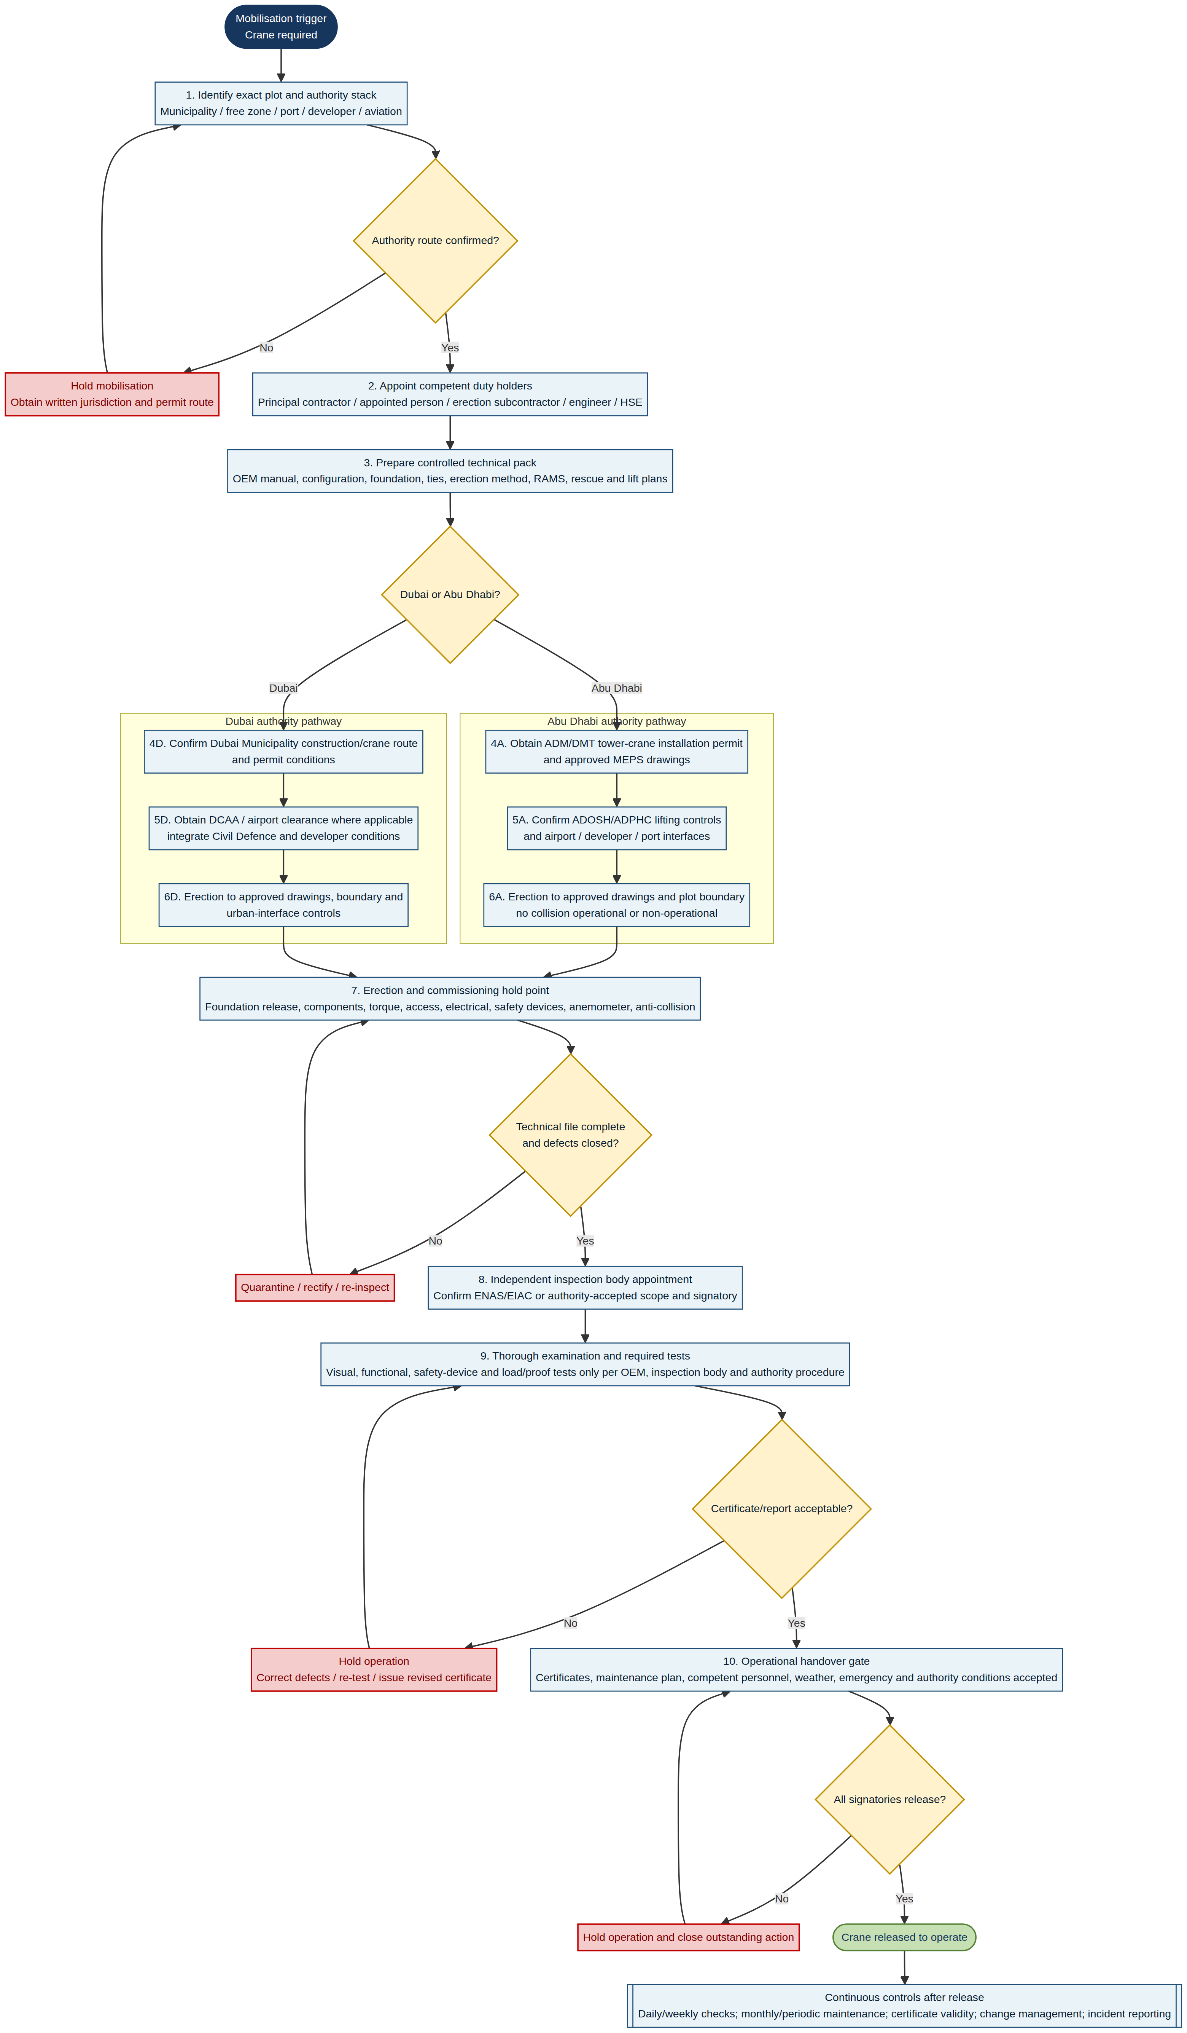
Figure A1. Controlled workflow visual. This appendix is a decision aid; current permit/NOC conditions, manufacturer instructions, project engineering and inspection-body requirements prevail.

Workflow Notes
Gate | Key rule
Authority route | Identify the exact plot and special-interface authority before mobilisation.
Engineering | Erection only to controlled OEM/engineering documents that match the approval record.
Certification | Independent testing/examination is an evidence gate; a missing or conditional certificate is a hold.
Operational handover | All named roles accept the technical file, maintenance/emergency controls and authority conditions before operation.
Change/incident | Major repair, configuration change, certificate/permit issue or incident reopens affected gates.

