FOOD-SAFETY PENALTIES & LICENSING COMPARISON
Camp kitchens, labour accommodation kitchens and catering operations — Dubai and Abu Dhabi
Scope | Penalty and enforcement consequence plus licensing comparison | Research date | 19-Aug-2026
Jurisdictions | Dubai Municipality and Abu Dhabi/ADAFSA | Document status | Working legal/compliance briefing
Prepared for | [Enter project/company] | Use | Validate with authority/counsel before reliance

Legal caution: The exact amount for a local inspection violation depends on the cited legal/schedule item, current amendment, risk classification, repeat history and enforcement notice. The analysis below distinguishes verified statutory amounts from local schedules whose itemised current amount was not publicly retrievable. It is not legal advice.

1. Executive Position
Food-safety enforcement in a camp kitchen can proceed on more than one level. The federal Food Safety Law provides specific criminal/financial penalties for harmful, adulterated, spoiled, misleading and technically non-compliant food and authorises administrative closure. Dubai also has a local public-health enforcement framework, while Abu Dhabi uses an ADAFSA risk-based administrative penalty schedule and escalation ladder. A single inspection can therefore result in corrective action, an administrative fine, product seizure/destruction, suspension or closure; serious cases may also engage the federal-law penalties. [1] [2] [3]

2. Exact Statutory Financial Penalties — Federal Law Applying Across the UAE
Conduct | Federal Law No. 10 of 2015 Penalty | Camp-Kitchen Example
Trading adulterated, harmful or spoiled food | At least 3 months’ imprisonment and AED 100,000–AED 2,000,000 fine, or either penalty. | Service of unsafe/contaminated/expired food; serious food-safety failure.
Unlicensed trading of food containing pork/alcohol/non-compliant Sharia material | At least 1 month’s imprisonment and AED 50,000–AED 500,000 fine, or either penalty. | Unapproved restricted ingredient/product handling.
False food description / misleading label | AED 10,000–AED 100,000 fine. | Misleading food description, incorrect label or untruthful food information.
Disposal or alteration of food held under custody without permission | 3 months–2 years’ imprisonment and AED 100,000–AED 300,000 fine, or either penalty. | Destroying/altering seized food or evidence without written authority approval.
Trading contrary to technical regulations | AED 10,000–AED 100,000 fine. | Non-compliance with applicable mandatory food technical regulation.
Other breach without a specific stated penalty | Fine not less than AED 10,000. Repeat offences: penalty doubled. | Failure to meet another duty under the law, subject to the facts and authority decision.

The federal Law additionally permits warning, administrative closure for up to three months, early resumption if the breach is removed, and final closure/licence-withdrawal request if the breach remains after administrative closure. The Executive Regulations confirm a 30-day appeal against administrative/final closure. [1] [2]

3. Dubai Municipality — Local Fine and Enforcement Structure
Verified Rule | Penalty / Consequence | How to Apply It
Dubai Local Order No. 11 of 2003 general sanction | AED 100–AED 500,000 for a breach of the Order, implementing bylaw, resolutions or instructions, unless a stricter penalty applies. | This is the verified local general range; do not assume it is the amount for every checklist finding.
Repeat same violation within one year | Fine doubled, capped at AED 500,000. | Review the prior inspection/violation history.
Local administrative measures | Suspend/revoke permit or licence for up to 1 month; disconnect water/electricity up to 3 months; confiscate/destroy non-compliant goods/materials; impound non-conforming vehicles. | May be imposed alongside/independently of a fine within the authority’s powers.
Failure to remedy within prescribed time | Authority may remedy and recover costs plus 25% administrative fees. | Treat corrective-action deadline as a financial-exposure trigger.
Inspection example | Dubai Municipality reported fines and temporary closures; closure remained until the cause was removed and conditions rectified. | Actual outcome depends on violation, risk, previous findings and notice.

The Dubai Local Order says the implementing bylaw determines the individual violation acts and prescribed penalty. This research did not locate a current official camp-kitchen-specific Dubai matrix mapping individual inspection items to fixed AED amounts. The federal-law amounts above remain relevant for conduct that falls within those statutory offences. [1] [4]

4. Abu Dhabi / ADAFSA — Fine Schedule and Escalation Structure
Verified Item | Penalty / Consequence | Limit / Current Status
Administrative fine schedule | ADAFSA Resolution No. 3 of 2021 covers 150 administrative violations; this includes 16 general violations and 22 food-facility health/hygiene and infrastructure/equipment violations. | The authority’s official index identifies a 2025 amendment (Decision No. 6 of 2025). Exact current AED amount per food-facility item was not publicly retrievable in this research.
Graduated administrative ladder | Notice; warning; financial/administrative/technical supervision; temporary activity suspension; service/programme suspension; licence cancellation/suspension; temporary/permanent closure. | Penalty is graduated according to risk and compliance history.
High-risk imminent serious effect | Temporary suspension of activity may apply. | Authority states this applies to high-level risk with imminent serious effect to public health.
High-risk/repeated/serious breach | Temporary or permanent closure may apply after escalation, serious harm not immediately removed, confirmed poisoning case or high-risk violation(s). | Official closure notices identify repeat high-risk breaches and ineffective corrective action as closure grounds.
Appeal/reconciliation | The 2022 framework states an appeal can be submitted within 60 days; absence of response within 90 days is acceptance. WAM’s 2021 report stated Resolution 4 gave a 25% reduction for certain reconciliations within 60 days. | Confirm present applicability and procedure after 2025 amendments for a specific case.

ADAFSA’s official closure notices state closure remains in force while its causes exist. Resumption follows only after rectification, fulfilment of requirements for the activity and removal of the causes of violation. Official examples identify pests, poor hygiene, inadequate storage and unlabelled food as high-risk issues in closure cases. [3] [5] [6]

5. Visual Licensing Comparison Chart
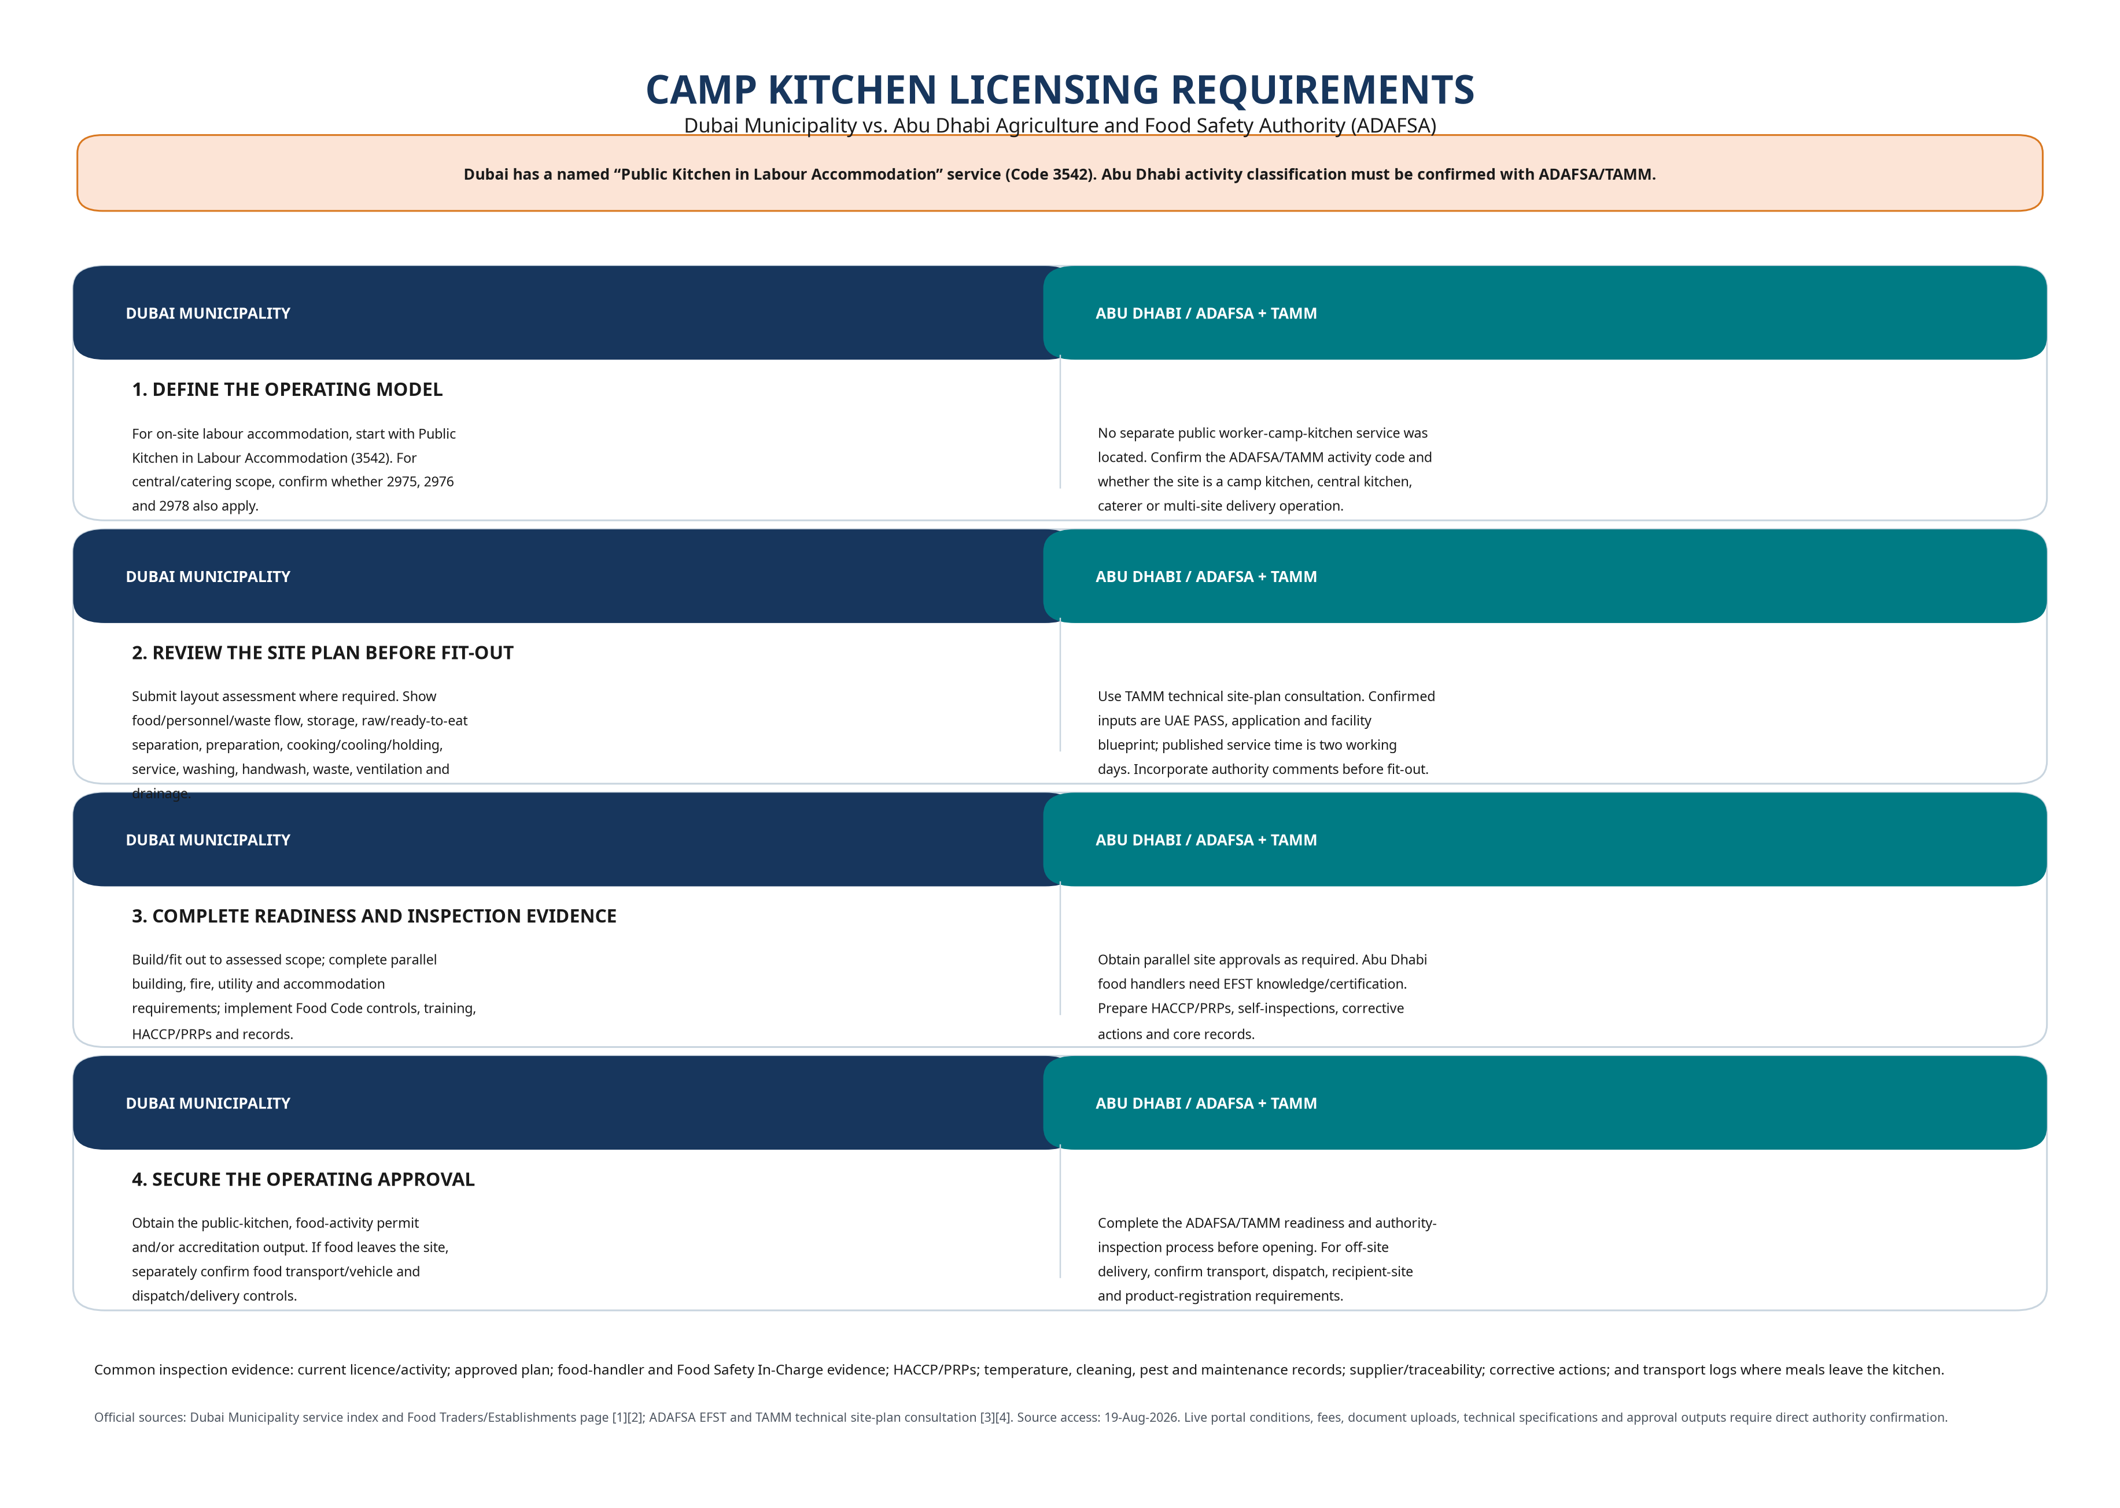
Figure 1. Licensing and approval route comparison — Dubai Municipality versus ADAFSA/TAMM.

6. Management Actions Before the Next Inspection
Priority | Action | Evidence
1 | Keep a register of every licence, food activity, layout approval, vehicle approval and authority inspection result. | Current approval file at site and digital archive.
2 | Review the legal activity against actual operation: on-site cooking, external catering, meal transport, recipient-site service and labour accommodation. | Signed activity-scope statement and authority confirmation.
3 | Prepare a repeat-offence control: close every inspection point with root cause, owner, due date, photo/document evidence and effectiveness review. | CAPA register and management review minutes.
4 | Hold the federal-law critical-risk items at zero tolerance: harmful/spoiled food, false food information, seized-food interference and technical-regulation breaches. | HACCP/CCP logs, traceability, withdrawal procedure and staff briefing.
5 | Obtain written confirmation of current local schedule item/amount if any violation notice is issued. | Notice, cited rule/schedule item, amount, time for response and appeal/reinspection instructions.

References
Ref. | Official Source
[1] | UAE Federal Law No. 10 of 2015 Concerning Food Safety — official text and penalties: https://uaelegislation.gov.ae/en/legislations/1161/download
[2] | Cabinet Resolution No. 26 of 2017, Executive Regulations — Article 22 administrative measures: https://uaelegislation.gov.ae/en/legislations/1160
[3] | Abu Dhabi Media Office, ADAFSA regulatory-penalty framework (Resolution No. 2 of 2022): https://www.mediaoffice.abudhabi/en/government-affairs/abu-dhabi-agriculture-and-food-safety-authority-reinforces-regulatory-penalties-to-reduce-improper-practices-and-protect-community/
[4] | Dubai Local Order No. 11 of 2003 Concerning Public Health and Community Safety: https://dlp.dubai.gov.ae/Legislation%20Reference/2003/Local%20Order%20No.%20(11)%20of%202003%20Concerning%20Public%20Health.html
[5] | WAM, ADAFSA issues two resolutions on violations and fines: https://www.wam.ae/en/article/hszrcoi2-adafsa-issues-two-resolutions-violations-and
[6] | ADAFSA closure notice / enforcement example: https://www.adafsa.gov.ae/en/mediahub/news/Pages/02042026.aspx
[7] | Dubai Municipality food-establishment services: https://www.dm.gov.ae/municipality-business/food-safety-department-2/important-information-to-food-establishment/
[8] | Dubai Municipality Food Traders and Establishments: https://www.dm.gov.ae/municipality-business/food-traders-establishments/
[9] | ADAFSA Essential Food Safety Training Program: https://www.adafsa.gov.ae/en/work/food-safety/Pages/training-program.aspx
[10] | TAMM Review Establishment Site Plan and Technical Consultation: https://www.tamm.abudhabi/en/life-events/individual/agriculture-livestock/farming/RequesttoReviewEstablishmentSitePlanandtechnicalconsultation

Source access date: 19-Aug-2026. The English translation of UAE legislation may not control where it conflicts with Arabic. Authority service details and fine schedules may be amended; confirm the live legal citation, schedule item and service conditions before relying on this document.

