Demobilisation & Site Handover Expansion: Utility and Environmental Clearance Controls
Document Information | Detail
Prepared for | Site Safety UAE
Purpose | Add final utility, environmental compliance and clearance controls to the demobilisation and client-handover workflow.
Comparison coverage | Dubai, Abu Dhabi and Sharjah mainland pathways; free-zone, master-developer, port and special-development routes must be confirmed separately.
Intended use | A configurable project-control checklist and management teaching aid, not legal advice or a substitute for current authority, utility or permit-condition confirmation.
Key product rule | Select the utility end state before creating a disconnection task. Permanent client services, temporary site services and demolition/redevelopment services follow different closure paths.

Executive guidance
The demobilisation section should add a formal Final Utility & Environmental Clearance Gate before temporary services, welfare, equipment or environmental controls are removed. The gate must distinguish three end states. A permanent supply that remains needed by the client should be transferred, energised and accepted, not disconnected. A temporary construction supply should be isolated, disconnected and removed only after the workface and client/authority dependencies are clear. A demolition or redevelopment project needs a separately confirmed utility-isolation/demolition route.

Never use a single “utility clearance” checkbox. Ask whether the permanent building supply remains live for the client, whether a temporary construction supply is to be removed, or whether the asset is being demolished/redeveloped. This decision determines the authority path, evidence and final action.

Dubai Electricity and Water Authority’s move-out service deactivates electricity and water from the premises and requires all previous DEWA bills to be paid before the request. DEWA distinguishes move-out and demolish deactivation routes. 1 Its Clearance Certificate is issued against cleared outstanding bills, is automatically issued after final-bill settlement and is valid for one month from issue. 2

Proposed new product block | What it should do | Management benefit
Utility End-State Decision | Require the project manager to select Transfer/Client Energisation, Temporary Supply Disconnection, or Demolition/Redevelopment Isolation. | Stops accidental disruption of a client’s permanent service and prevents temporary accounts from remaining open.
Utility Asset & Account Register | Record meter/account number, service type, permanent/temporary classification, account holder, location, isolation point, closure route, final bill and evidence. | Ensures every live energy, water, gas, telecom or temporary connection is owned and closed correctly.
Environmental Permit Applicability | Ask whether the project/facility holds an environmental permit, environmental-clearance conditions, waste permit, monitoring obligation, spill/contamination risk or land-reinstatement requirement. | Avoids treating ordinary waste collection as full environmental closeout.
Clearance Evidence Pack | Attach utility request, isolation certificate, meter removal/transfer confirmation, final bill, clearance certificate, waste-transfer records, rehabilitation evidence, permit cancellation and client sign-off. | Gives the client a traceable closeout record.
Authority-Ready vs Client-Ready Status | Maintain separate statuses for authority/utility clearance and client acceptance. | Makes it visible when the works are complete but a client, utility or permit condition still blocks handover.

1. Required demobilisation decision gate
Question | If yes | If no / alternative | Checklist output
Will the completed asset need permanent electricity/water/gas/telecom service immediately after handover? | Select Transfer / Energisation / Client Account. Agree the client account holder, meter, energisation evidence and client acceptance. | Proceed to the next question. | Do not create a permanent-supply disconnection task.
Is the service a temporary construction or welfare supply? | Select Temporary Disconnection / Removal. Plan isolation, final reading, disconnection, removal and account closure. | Confirm whether the service is permanent or an embedded developer supply. | Create temporary-service closure tasks.
Is the building/area being demolished, redeveloped or returned vacant? | Select Demolition / Utility Isolation. Confirm all asset disconnections, authority permits, demolition controls and reinstatement conditions. | Use transfer or temporary-disconnection route as applicable. | Create demolition/redevelopment utility and environmental checklist.
Does a free zone, master developer, landlord, district-cooling provider, gas company, telecom provider or client have a separate procedure? | Add it to the authority register and link its NOC/clearance to this gate. | Record the confirmation source. | Add a conditional authority card; do not assume the emirate-level service is sufficient.

2. Authority-specific final-clearance requirements

Dubai
Control | Minimum evidence to retain | Timing shown in the tool | System rule
DEWA move-out deactivation, where the premises is being closed | Service request, paid-account confirmation, requested disconnection date/time, final bill and completion confirmation | Start planning at least four to six weeks before final demobilisation; this is a project planning allowance, not a published DEWA SLA. | Do not mark complete until the final bill is settled and service/action completion is recorded. DEWA states all previous bills must be paid before the move-out request. 1
DEWA demolish route, where the premises is to be demolished | Demolition-specific service request, authorised isolation/disconnection evidence and project demolition approvals | Trigger before demolition mobilisation, not after site vacating. | Offer this route separately from ordinary move-out. 1
DEWA Clearance Certificate | Clearance Certificate and settled final bill; issue and expiry date | Published validity: one month from issue. 2 | Alert at 14 days and 7 days before expiry if the certificate is being relied upon for client/landlord/authority handover.
Dubai environmental requirements, where an environmental clearance/permit or its conditions apply | Permit/clearance reference, conditions register, monitoring/inspection records, waste records, reinstatement evidence and closure/confirmation correspondence | Begin condition review with the closeout workshop; do not wait for the final week. | Mark as conditional. The exact project activity, permit conditions, development authority and land status determine the closure evidence.

Abu Dhabi
Control | Minimum evidence to retain | Timing shown in the tool | System rule
TAQA Distribution or applicable utility route | Correct service route selection: transfer, removal, temporary shutdown or account closure; request reference, field/work confirmation, account/final-bill evidence where applicable | Start planning at least four to six weeks before final demobilisation; this is a project planning allowance, not a published TAQA commitment. | Require the assigned utility coordinator to identify the service and account owner. Do not close an account that is required for client operation.
DMT/site-clearance or utility-assets interface, where applicable | Site/plot details, utility-assets clearance evidence, NOCs or closure confirmation | Resolve at the authority/utility closeout workshop. | Create a conditional site-clearance card for demolition, redevelopment, removal or affected utility assets.
EAD environmental licence cancellation for an industrial facility | TAMM cancellation application/reference and final approval | TAMM presents an estimated six-minute service duration; treat it as portal service time, not the total project environmental-closeout duration. 3 | Use only where the facility holds the relevant EAD environmental licence. It is not a generic construction-completion certificate.
EAD/permit-specific environmental closure | Permit conditions, waste/disposal documentation, monitoring evidence, remediation/reinstatement evidence, regulator/client correspondence | Begin at least six weeks before final handover if conditions, hazardous materials or industrial activities apply. | Require an environmental consultant/permit-holder confirmation of the final condition and whether a cancellation, variation, monitoring report or no further action is needed.

Sharjah
Control | Minimum evidence to retain | Timing shown in the tool | System rule
SEWA or applicable utility route | Correct service route, account/meter details, temporary/permanent classification, final bill/closure or transfer confirmation | Start planning at least four to six weeks before final demobilisation; this is a project planning allowance, not a published SEWA commitment. | Use the client/developer’s confirmed SEWA route. Make the service request and final confirmation mandatory evidence.
Municipal cancellation of environmental permit to practise an activity | Rehabilitation evidence, equipment-removal record, vacant-land confirmation and permit-cancellation approval | Rehabilitation/removal must finish before cancellation application; start at least six weeks before handover if it applies. | Sharjah Municipality describes this as approval to cancel the activity permit after rehabilitation, equipment removal and vacating the land. 4
Waste, equipment and reinstatement closeout | Waste-transfer records, equipment inventory/removal evidence, final site photos, rehabilitation/reinstatement acceptance | Track progressively; do not batch at the final week. | Waste removal alone is insufficient where a municipal environmental activity permit applies; require the cancellation route and final approval. 4

3. Expanded utility and environmental-clearance checklist
The following checklist should appear in a separate Utility & Environmental Clearance tab, linked to the project dashboard and demobilisation checklist. Every record should support owner, target date, reference, file link, approval status, reason for not-applicable, expiry date and escalation.

ID | Clearance control | Applies when | Evidence / completion standard | Suggested owner
UE-01 | Select final utility end state | Every project | Transfer/energisation, temporary removal or demolition/isolation option selected and client confirmed | Project manager
UE-02 | Create utility and asset inventory | Every project | Account/meter/service register for power, water, gas, telecom, drainage, district cooling and temporary systems | Utility coordinator
UE-03 | Classify each service as permanent or temporary | Every project | Client/consultant sign-off on classification; isolation points identified | MEP manager
UE-04 | Confirm account holder and financial liability | Every project | Named account holder, final-bill owner and deposit/refund responsibility | Commercial manager
UE-05 | Plan permanent service transfer or energisation | Client will operate asset | Client account/transfer/energisation evidence, meter status and client acceptance | Utility coordinator
UE-06 | Request temporary service disconnection/removal | Temporary site service ends | Authority/utility request, planned isolation date and method statement | Utility coordinator
UE-07 | Confirm demolition/redevelopment isolation route | Asset/area will be removed or redeveloped | Demolition-specific utility action and relevant permits/NOCs | Consultant + utility coordinator
UE-08 | Isolate temporary electrical, water, gas and telecom systems | Before removal | Isolation certificate, lockout evidence, final reading and safe removal record | MEP manager
UE-09 | Settle final bill and obtain clearance/closure evidence | Account/service is closing | Settled final bill, final invoice and provider closure/clearance certificate where available | Commercial manager
UE-10 | Capture DEWA certificate validity if Dubai route is used | Dubai clearance certificate used | Issue date and one-month expiry date captured; client/landlord use complete before expiry | Document controller
UE-11 | Confirm environmental permit/clearance applicability | Every project | Permit register checked; decision and confirmation source recorded | HSE/environment manager
UE-12 | Close environmental-permit conditions | Permit/clearance has conditions | Conditions checklist, monitoring records, authority correspondence and final confirmation | HSE/environment manager
UE-13 | Retain waste and hazardous-material records | Waste/hazardous materials generated | Approved contractor evidence, manifests/transfer notes, disposal records and inventory reconciliation | HSE/environment manager
UE-14 | Inspect for spills, contamination or remediation need | Fuels, chemicals, generators, workshops, stores or hazardous materials used | Inspection record, corrective action/remediation evidence and environmental consultant statement where required | HSE/environment manager
UE-15 | Remove equipment and rehabilitate/reinstate site | Site/facility is closing or permit requires it | Removal inventory, final photos, rehabilitation and land/site acceptance record | Construction manager
UE-16 | Submit EAD industrial environmental-licence cancellation | Abu Dhabi industrial facility holds relevant licence | TAMM application and final cancellation confirmation | Permit holder / environmental manager
UE-17 | Submit Sharjah environmental activity-permit cancellation | Sharjah activity permit applies | Rehabilitation, equipment-removal and vacant-land evidence plus cancellation approval | Permit holder / environmental manager
UE-18 | Close third-party/client/master-developer conditions | Developer/zone/landlord route applies | NOC/clearance/acceptance by the identified responsible party | Project manager
UE-19 | Conduct authority-ready and client-ready review | Before acceptance and demobilisation release | Two separate status decisions, open exceptions and owners | Project director
UE-20 | Archive final clearance dossier | At final closeout | Indexed evidence pack linked to authority/client references | Document controller

4. Comparative approval stages and timeframes
The visual timeline is a closeout planning model, not a statement of guaranteed authority response time. It deliberately shows shared preparation windows for all three emirates because project duration is usually driven by completeness, site inspections, utility asset conditions, permit conditions, developer requirements and client decisions. The only two explicit service-time values in the comparison are the EAD industrial-licence cancellation portal’s estimated six minutes and DEWA’s one-month clearance-certificate validity. 2 3

Stage | Dubai | Abu Dhabi | Sharjah | Planning rule
T-6 to T-4 weeks | Confirm DEWA end state, account ownership and environmental conditions | Confirm TAQA/end-state route, affected utility assets and EAD permit scope | Confirm SEWA/end-state route and municipal environmental-permit applicability | Start before the final sprint; establish account and authority responsibility.
T-4 to T-2 weeks | Prepare deactivation/transfer and final-bill evidence | Prepare utility route and permit-condition/waste closeout evidence | Complete rehabilitation, equipment removal and vacant-land evidence where permit applies | Complete actual physical and documentary prerequisites, not merely the application form.
T-2 weeks to handover | Settle final bill; retain DEWA clearance certificate if applicable | Submit conditional EAD industrial-licence cancellation / confirm authority closure | Submit conditional environmental activity-permit cancellation | Submit only when prerequisite work and supporting evidence is genuinely complete.
Handover / final demob | Client/authority ready sign-off and archive | Client/authority ready sign-off and archive | Client/authority ready sign-off and archive | Do not release demobilisation until residual risks and live services are controlled.
Post-handover | Use Dubai Clearance Certificate within one-month validity where required | Retain permit and utility closure record | Retain municipal cancellation and restoration record | Close accounts, permits and access; retain complete dossier.

5. Visual appendix

Comparative workflow: final utility and environmental clearance
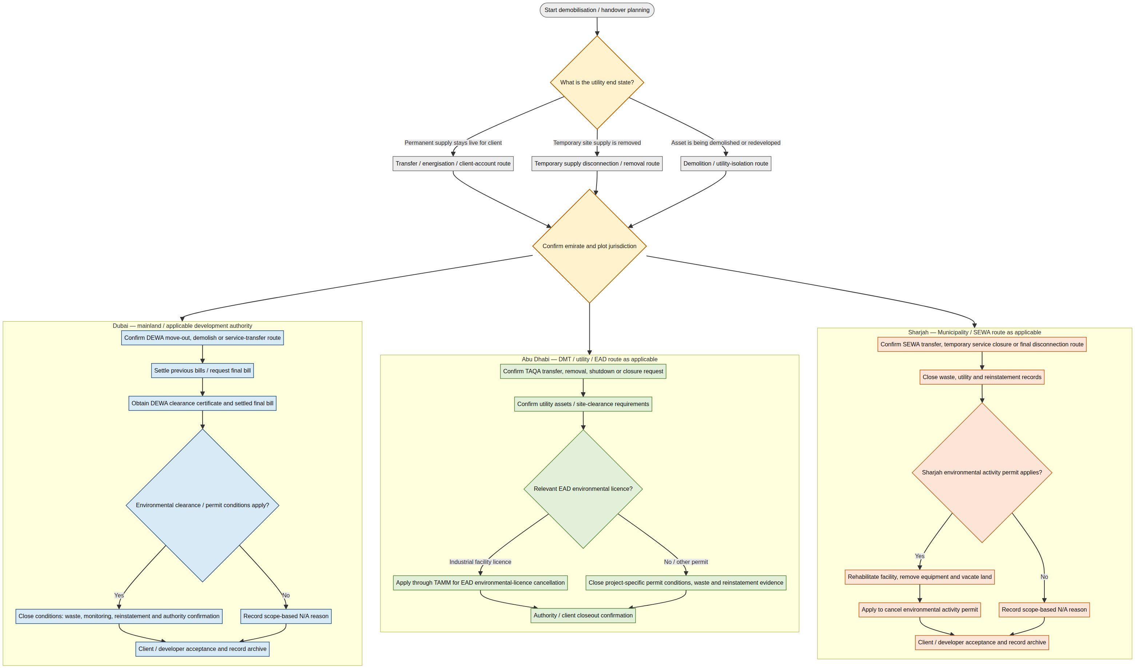

Comparative closeout timeline
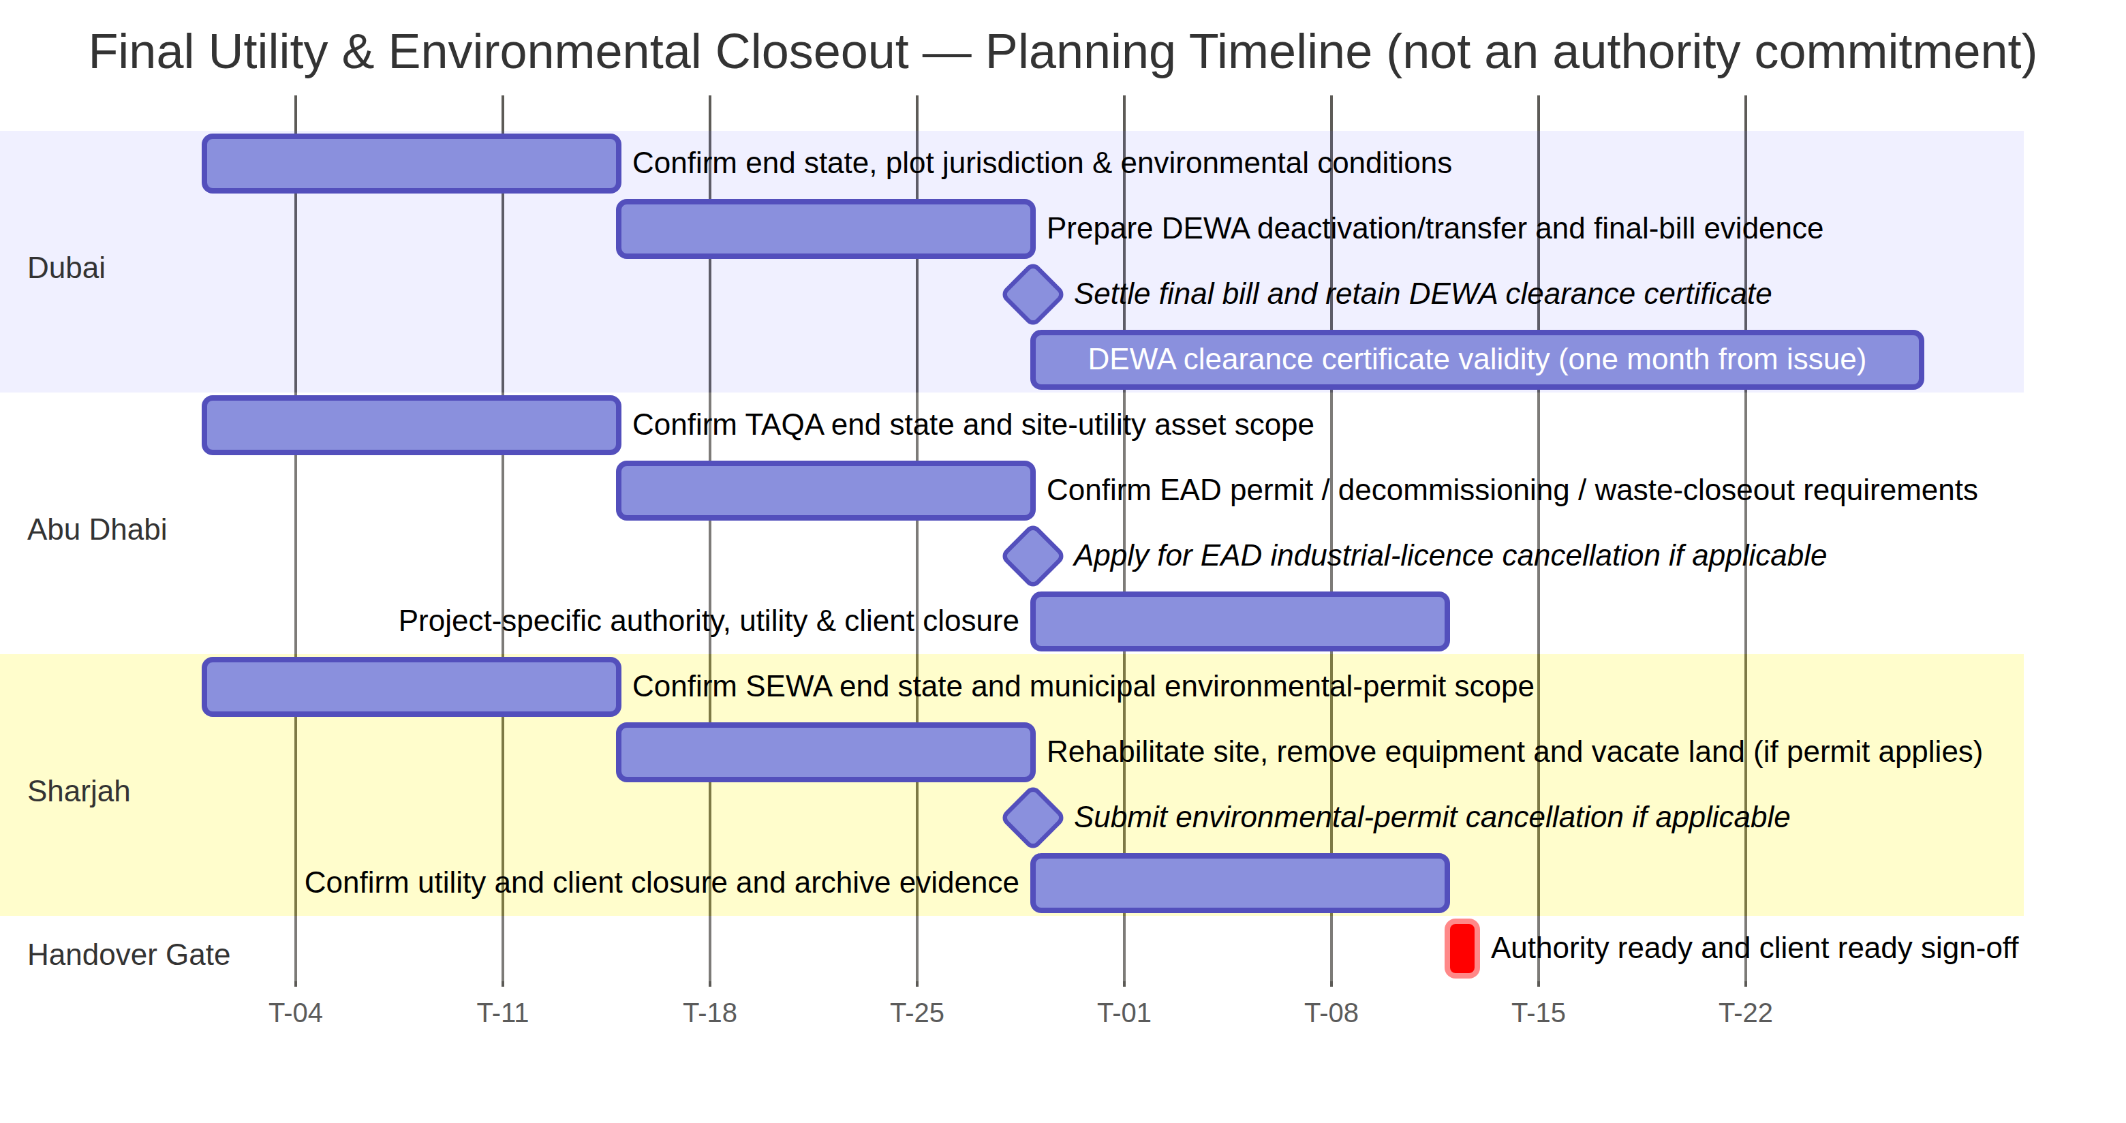

Product copy to add to the page
Final Utility and Environmental Clearance

Before demobilisation, confirm whether the completed asset’s permanent services will transfer to the client, temporary site services will be disconnected, or a demolition/redevelopment isolation is required. Attach the final utility evidence, environmental permit/clearance conditions, waste and rehabilitation records, and authority/client confirmation before releasing final removal works.

Environmental scope check

Environmental cancellation or clearance is project-specific. It may depend on a permit, activity, industrial licence, waste/hazardous-material risk, monitoring condition, land rehabilitation obligation, or master-developer requirement. Record the authority confirmation and reason if the item is not applicable.

References

Source and timeframe note. These controls are designed for client and management visibility. They do not replace the active permit, utility-provider instructions, appointed consultant or free-zone/master-developer route. Where a published authority SLA could not be verified, this guide gives a clearly labelled project planning allowance rather than a service commitment.

